**Assignment 3 & 4: Create Database and Collections with Screenshots**

**Step 1:**

Create Database

Database1: use db1

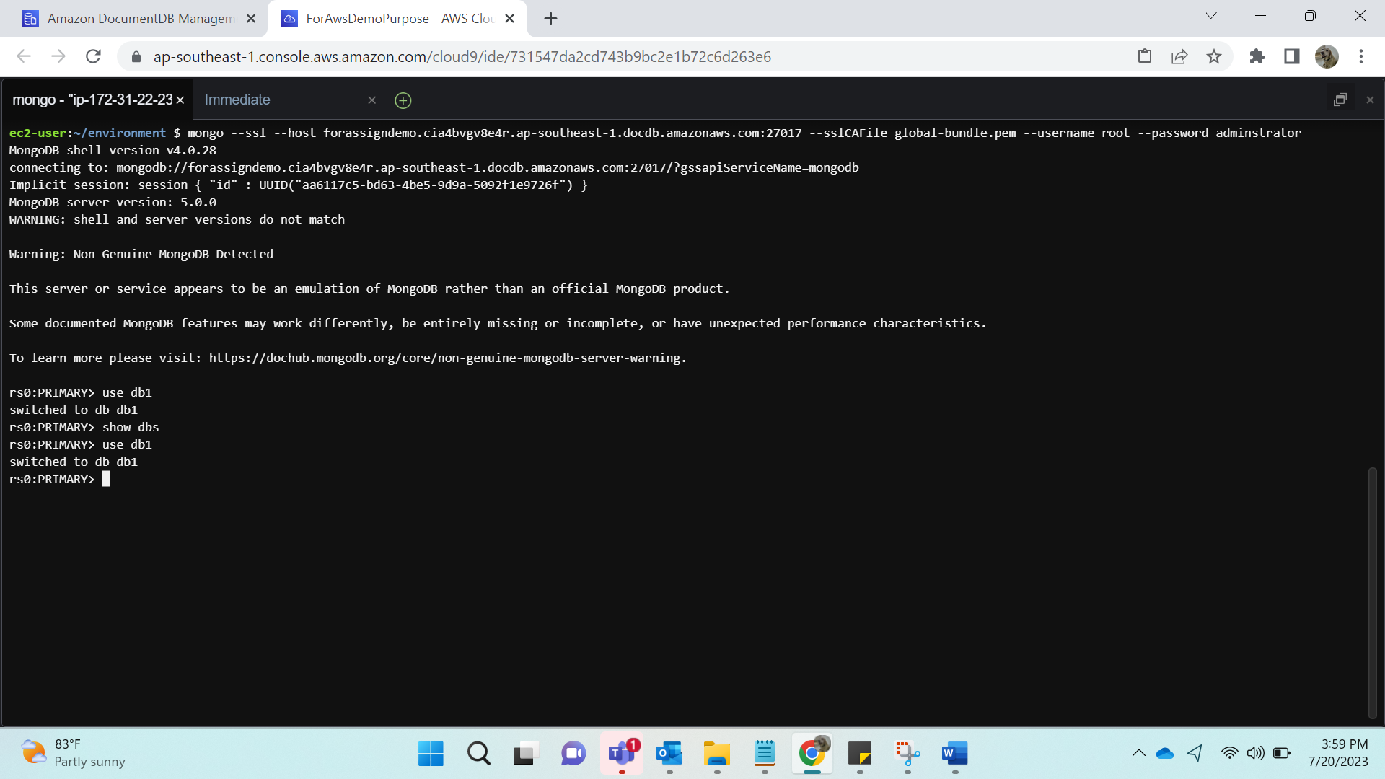

**Step 2:**

Create Collection

Collection1:

db.table1.insertMany([

{ "_id" : 1, "name" : "Ajay", "status": "active", "level": 9,"score":99},

{ "_id" : 2, "name" : "Priya", "status": "inactive", "level": 5,"score":88}

])

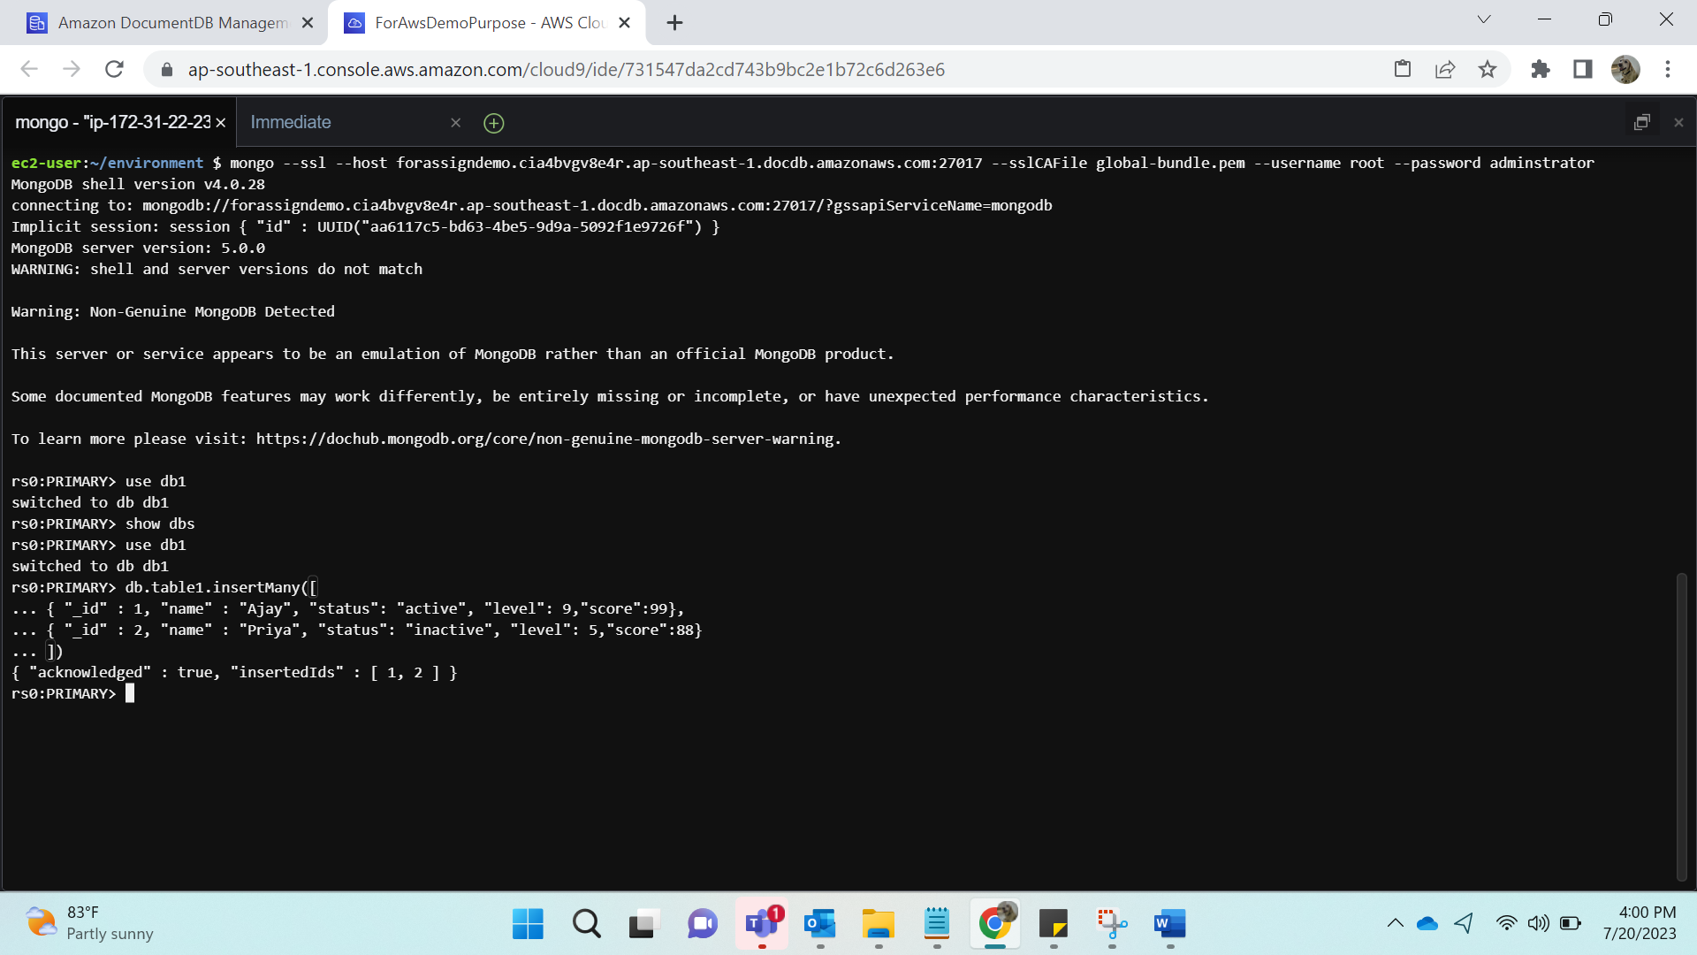

Collection2:

db.table2.insertMany([

{ "_id" : 1, "name" : "Ashish", "status": "active", "level": 10,"score":100},

{ "_id" : 2, "name" : "Santwana", "status": "inactive", "level": 8,"score":50}

])

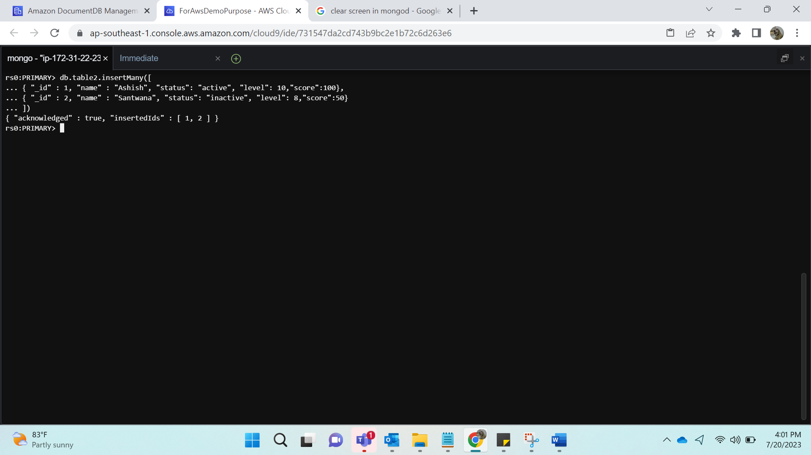

**Step 3:**

**Database** 2: use db2

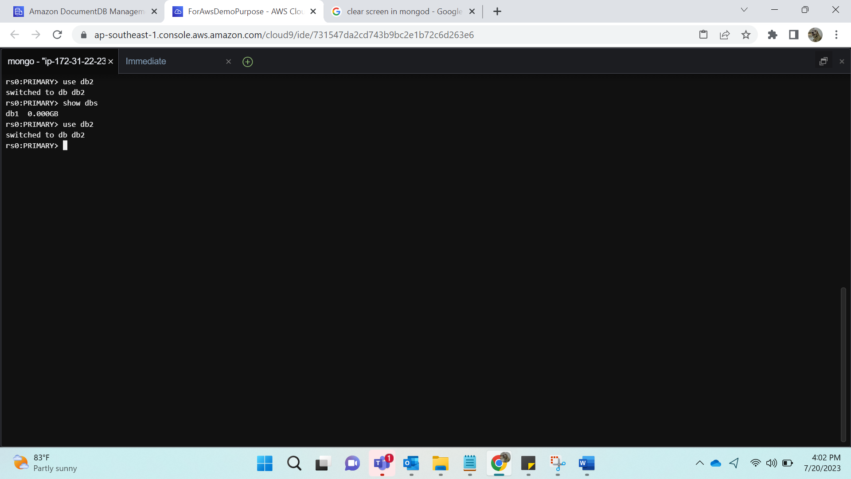

**Step 4:**

**Collection3**:

db.table3.insertMany([

{ "_id" : 1, "name" : "Amruta", "status": "active", "level": 1,"score":40},

{ "_id" : 2, "name" : "Avadhoot", "status": "inactive", "level": 4,"score":60}

])

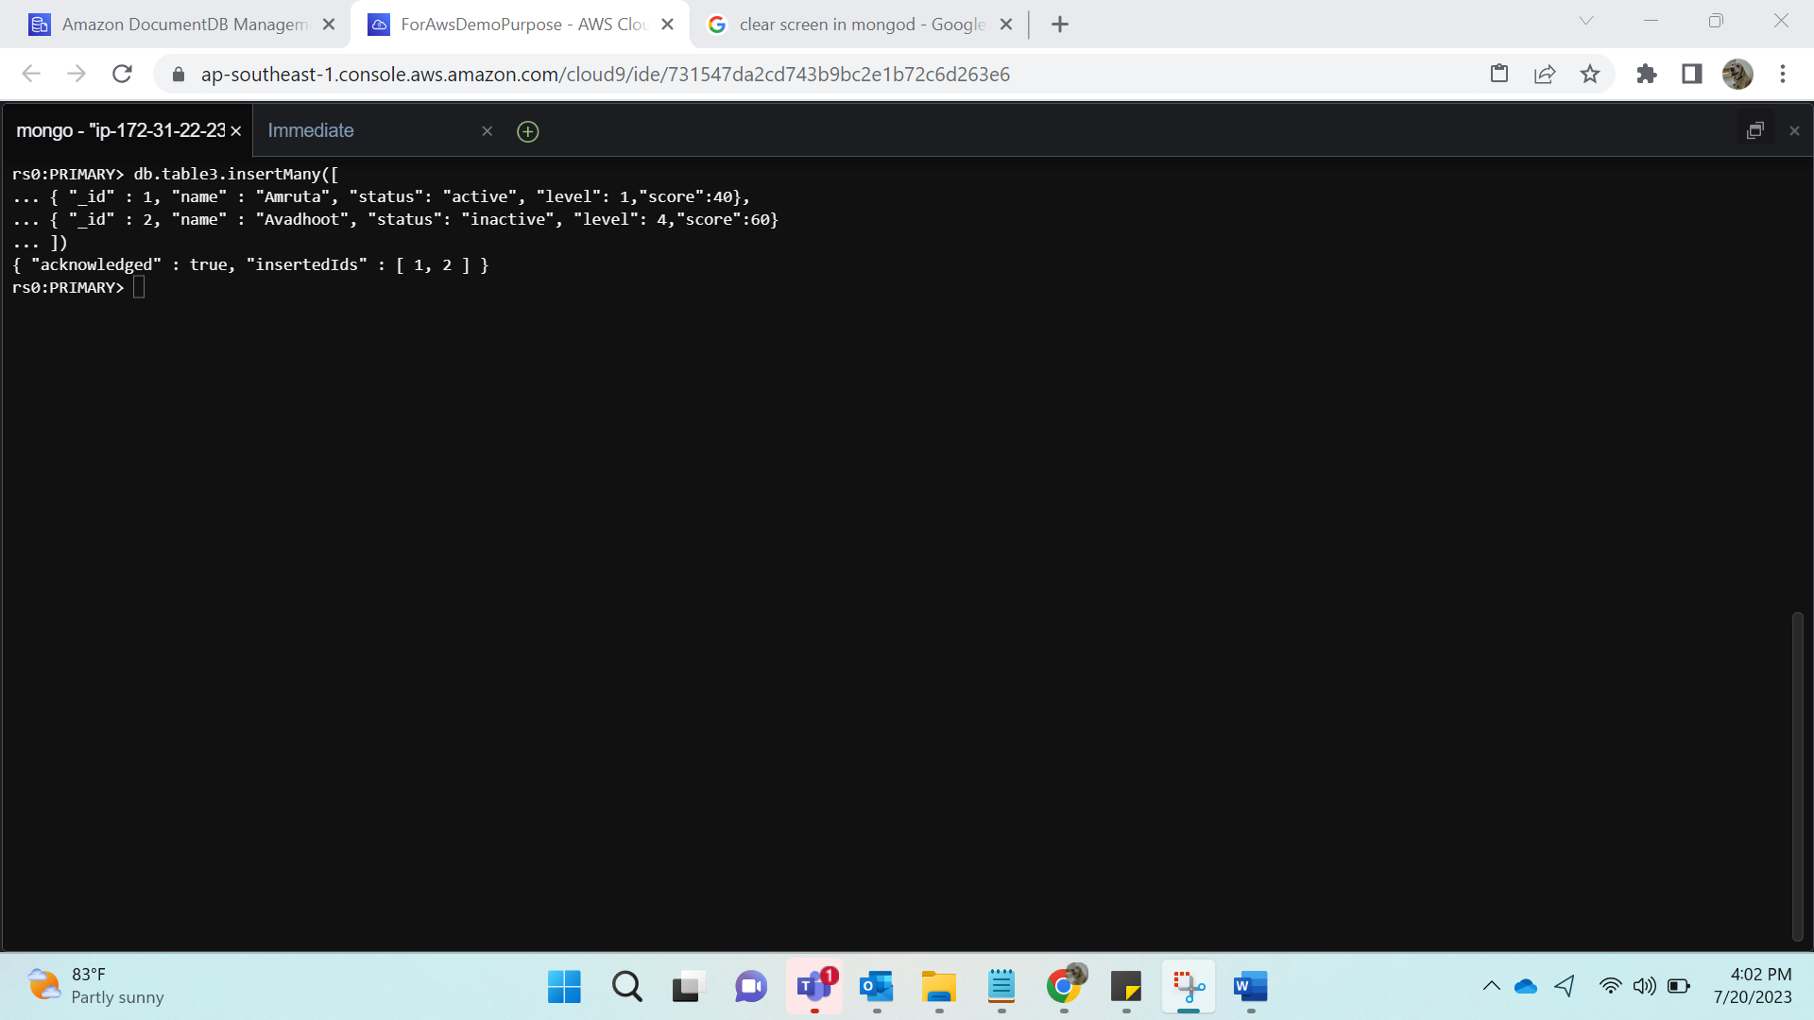

**Collection4**:

db.table4.insertMany([

{ "_id" : 1, "name" : "Vaishnavi", "status": "active", "level": 8,"score":8},

{ "_id" : 2, "name" : "Abhishek", "status": "inactive", "level": 8,"score":9}

])

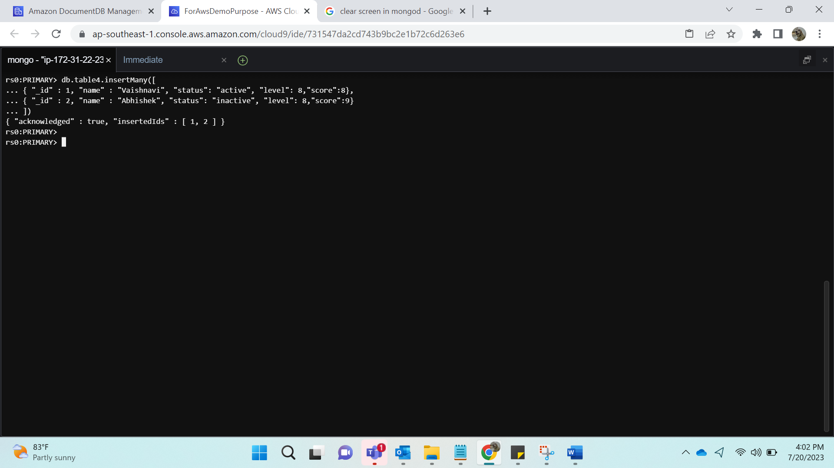

Use database101 will not create a database, we need to add data in it.

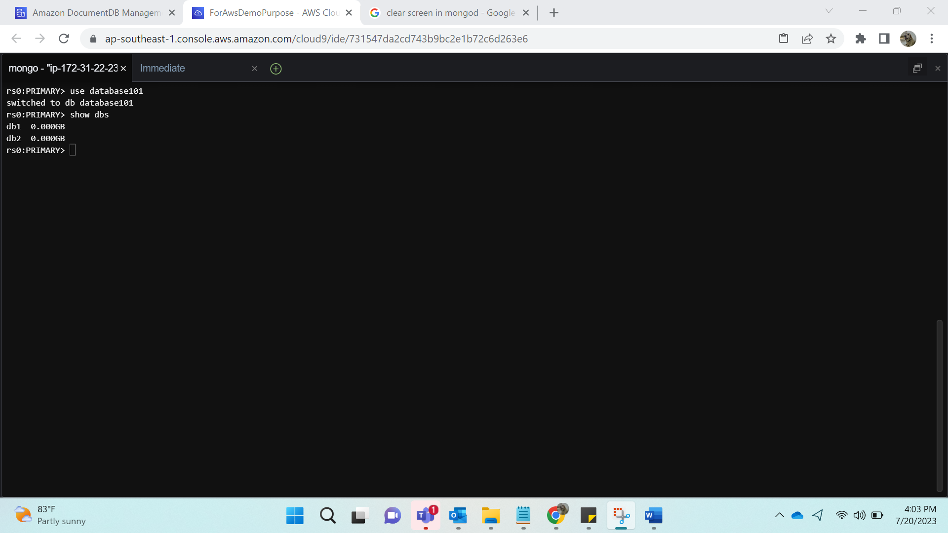

Checking the Inserted Data:

Show databases:

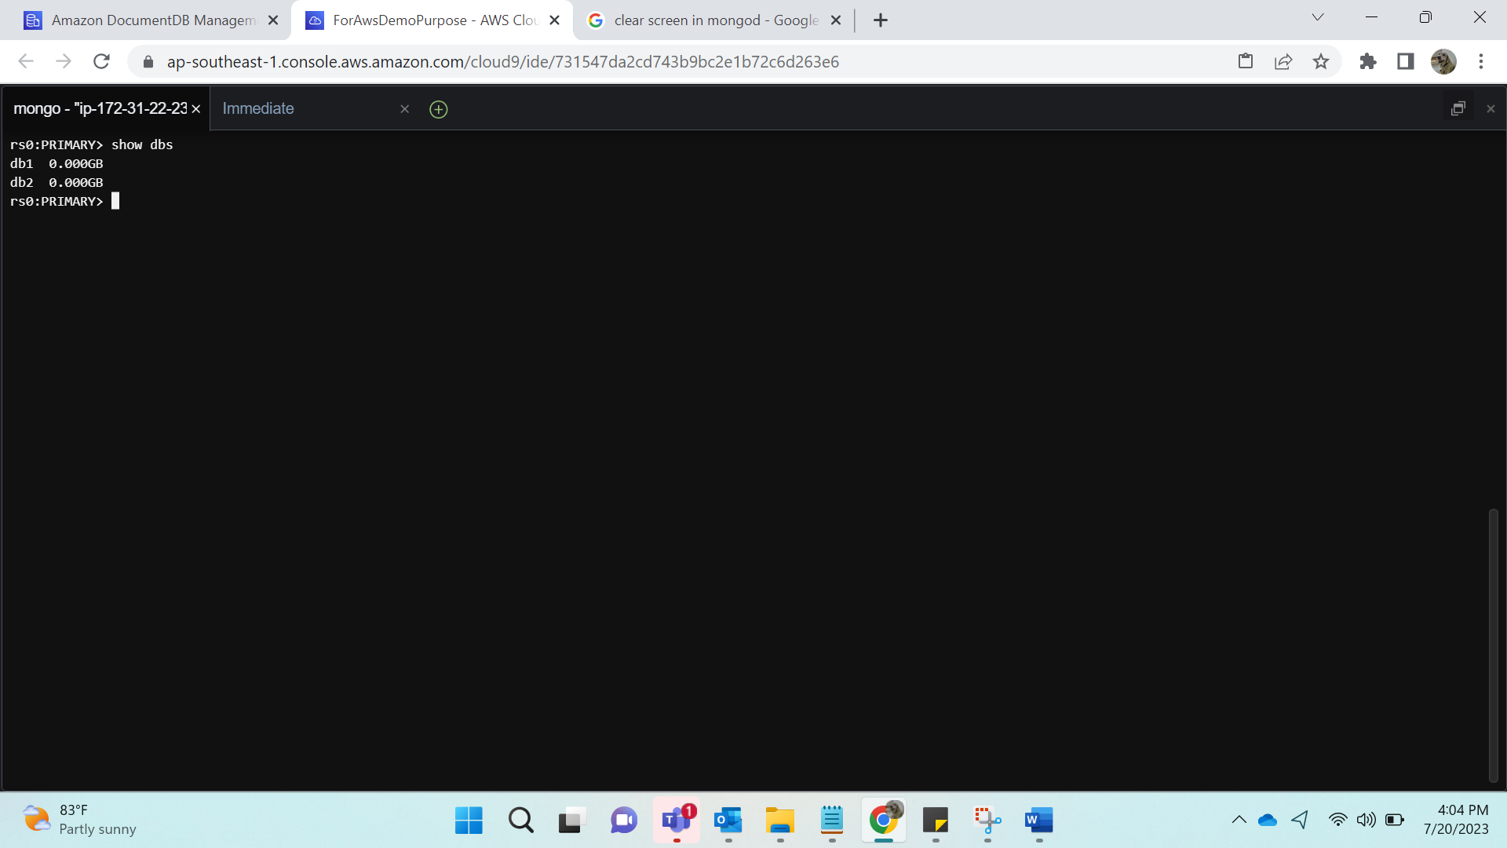

Show collections:

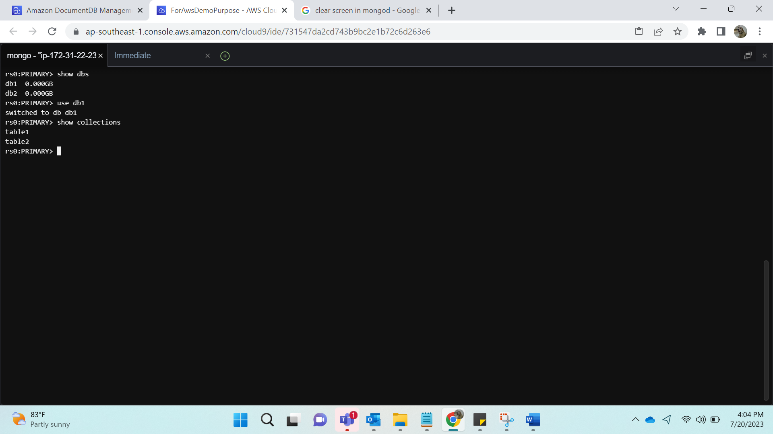

Show collection 1 data:

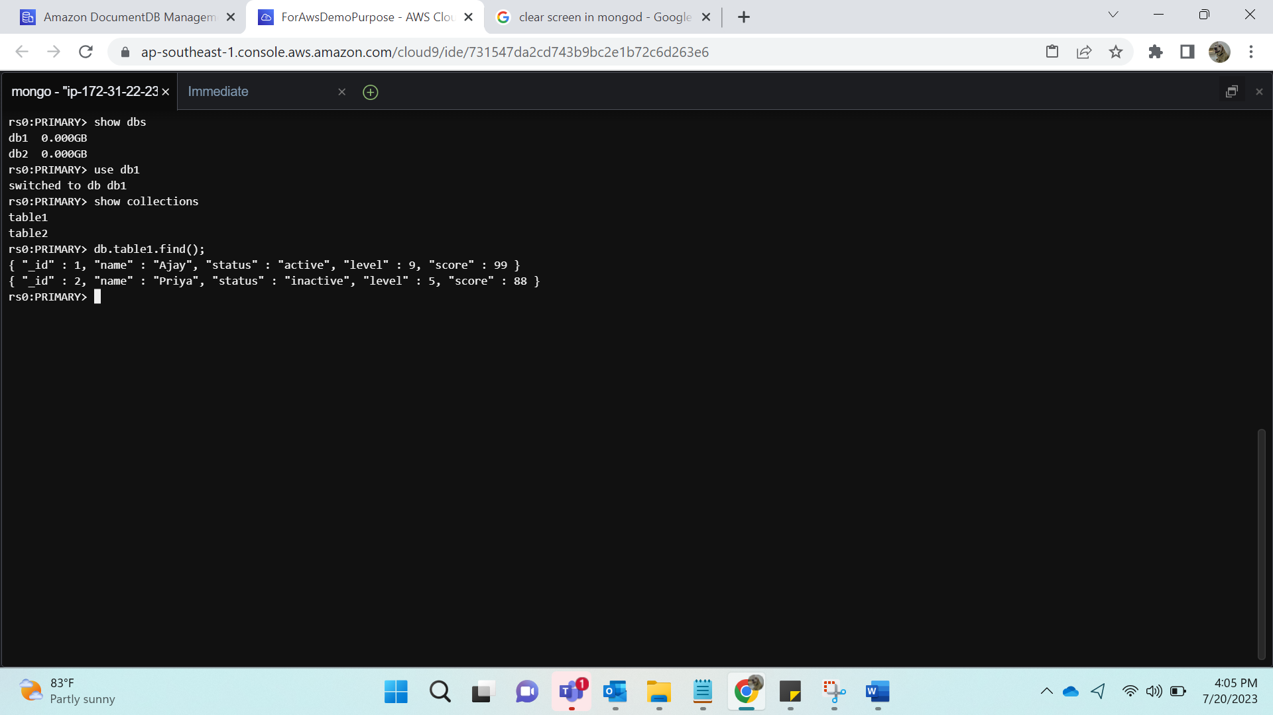

Show collection 2 data:

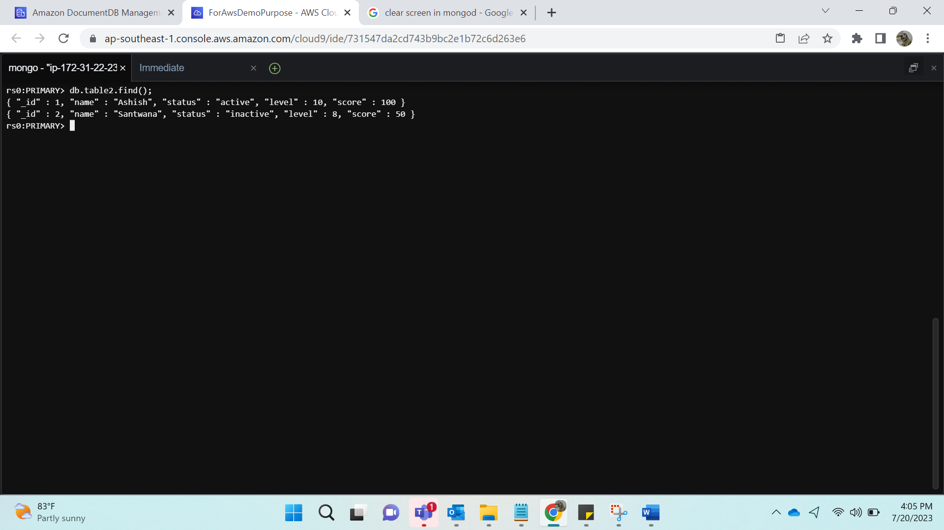

Showing database 2 and collections:

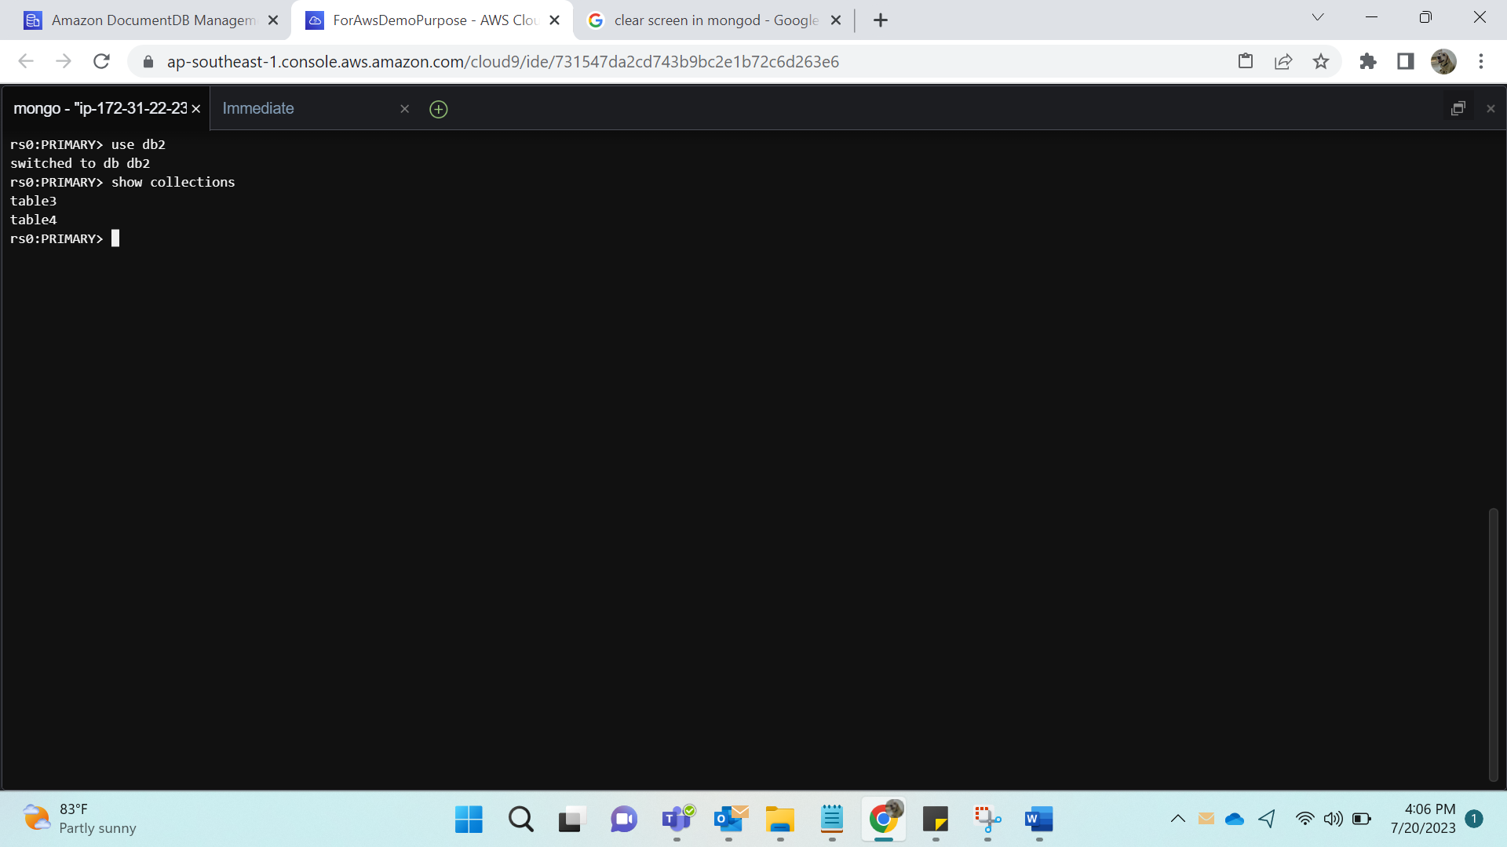

Show collection 1 data:

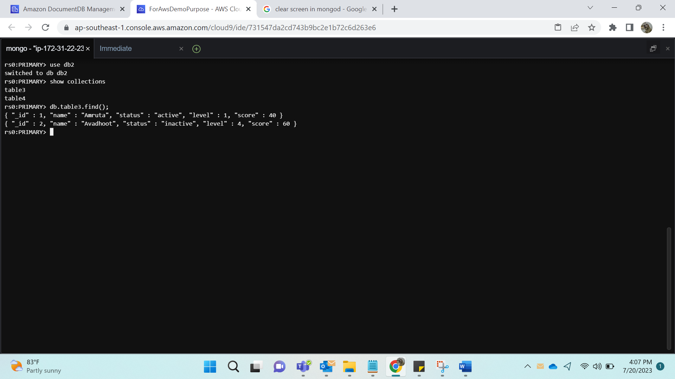

Show collection 2 data:

